
Certificate of Training
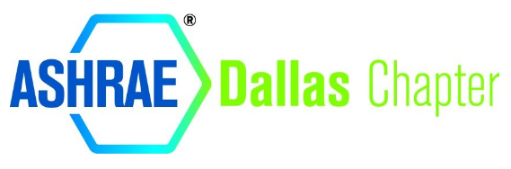
RRRRRR
Best Practices for Creating Good Indoor Air Quality
for Indoor Pool Environments
Jody M. Craft
Paddock Industries
HAS COMPLETED ONE HOUR OF PROFESSIONAL DEVELOPMENT & 0.1 continuing education credit (ceu) is awarded in
COURSE GUIDE
This certificate shall serve to affirm that
The holder of this document
on this 8th of febrUARY 2023

