
Certificate of Training
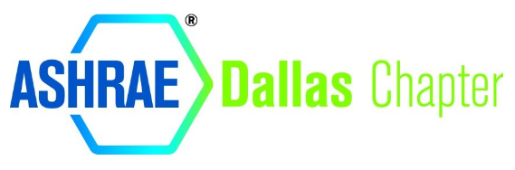
RRRRRR
Design Concepts in DOAS: Balancing IAQ and Energy
Brian Monk, P.E.
Carrier
HAS COMPLETED ONE HOUR OF PROFESSIONAL DEVELOPMENT & 0.1 continuing education credit (ceu) is awarded in
COURSE GUIDE
This certificate shall serve to affirm that
The holder of this document
on this 10th of May 2023

